QUESTION 3:

Step 1: Enter the student data
Open Excel and enter the following data starting from cell A1.
Roll No. | Student Name | English | Maths | Science | Computer | Social
101 | Rahul | 85 | 90 | 78 | 95 | 82
102 | Priya | 92 | 88 | 91 | 96 | 89
103 | Arjun | 76 | 80 | 85 | 82 | 79
104 | Sneha | 89 | 94 | 87 | 91 | 93
105 | Kiran | 81 | 75 | 80 | 86 | 78

Step 2: Apply formatting
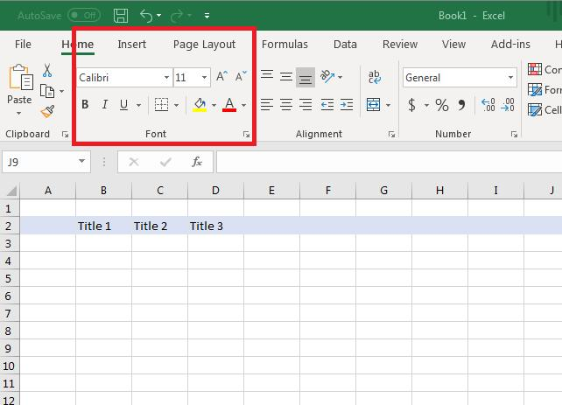
1. Format the headings
- Select cells A1:G1.
- Click Bold (B).
- Choose a background color using Fill Color.
- Change the font color if required.
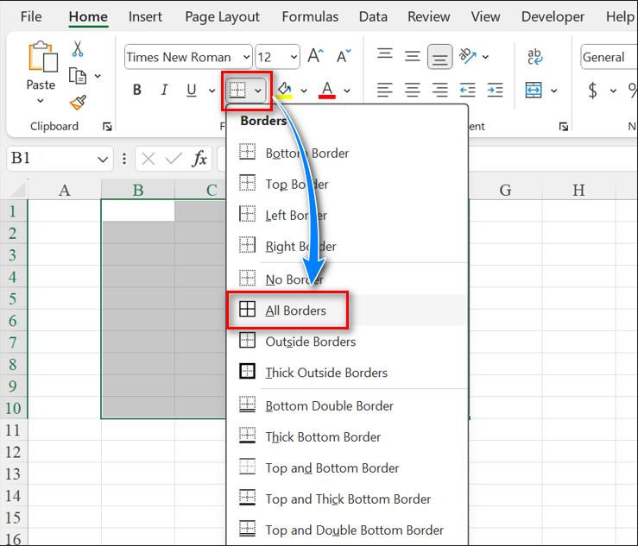
2. Apply borders
- Select the entire table, A1:G6.
- Go to Home → Borders.
- Choose All Borders.
- Optionally apply Thick Outside Borders for the outer boundary.

3. Apply alignment
- Select cells A1:G6.
- Go to Home → Alignment.
- Click Center for horizontal alignment.
- Click Middle Align for vertical alignment.
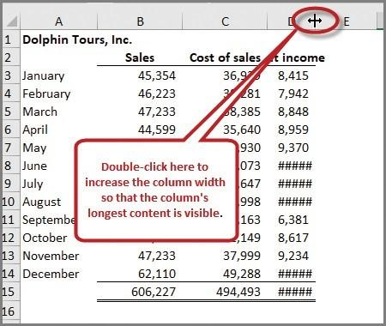
4. Adjust column width
- Select columns A to G.
- Go to Home → Format → AutoFit Column Width.
- This makes the headings and data fit properly.

Step 3: Final result
Your Excel worksheet will contain a student marks table with:
- Five subjects for each student.
- Bold and colored headings.
- Borders around all cells.
- Centered and vertically aligned data.
- Proper column widths.
Result: A neatly formatted student table in Excel using borders, font formatting, and alignment.

